**Multimedia & Graphics**

**Class Six**

**Lab 20**

|  |
| --- |
| Lab Objectives: Poster Designing ( Flyer) |

# What is Flyer?

## A flyer is a form of paper advertisement intended for wide distribution and typically posted or distributed in a public place, handed out to individuals or sent through the mail.

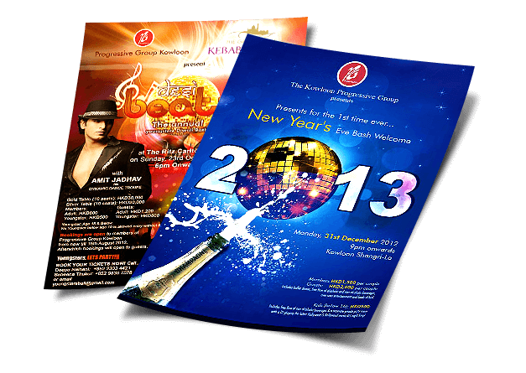

In this lab we will design a flyer.

# Scenario:

Suppose you are the owner of a fashion house.In this summer you will launch a discount offer upto 70% for all types of cloths. This offer will be validated for a limited time only.

# Core Attributes of this poster:

1. The name of your fashion house. Suppose it is ***“ [Your Name] Fashion” .***
2. Your offer name. Suppose you want to name it as ***“Spring Dhamaka Offer”***. (Dhamaka is a Bengali word. Typically it is used to make understand something big or especial.)
3. Discount title like “Get upto 70% discount for all of your favourite cloths”
4. Date and time. Let the offer will validate from March 10 - March 17, from 10 am to 5 pm
5. House location (any address)

# Let’s get started

Go to <https://www.canva.com/> . Canva provides you free templates ( pre designed editable poster) to make your poster easily.

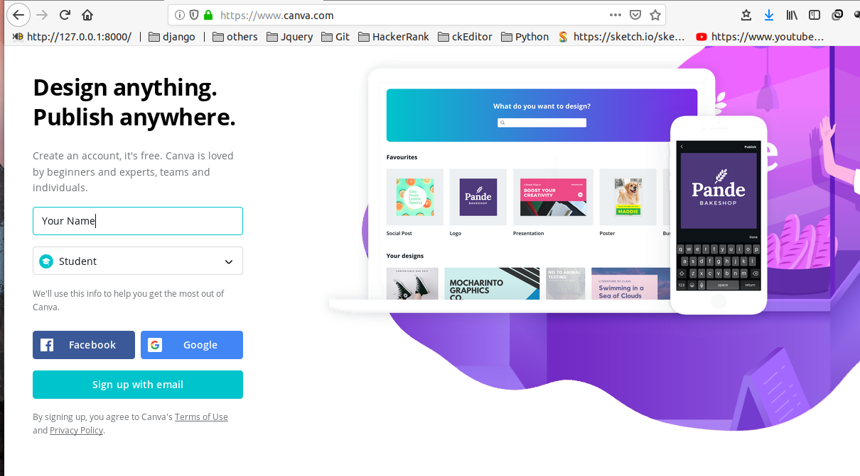

Sign up with your email. If you can’t ask help from your teacher. After signing in you will see the home page with a search box.

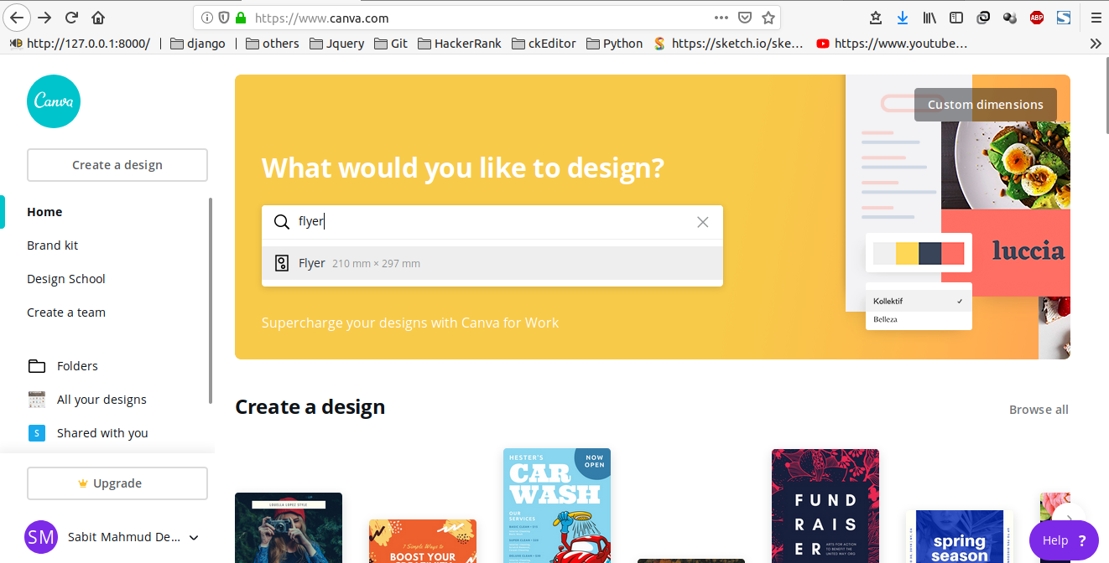

Type flyer and you will see the suggestion of flyer. Click that then you will find a bunch of flyer templates. Select one of them.

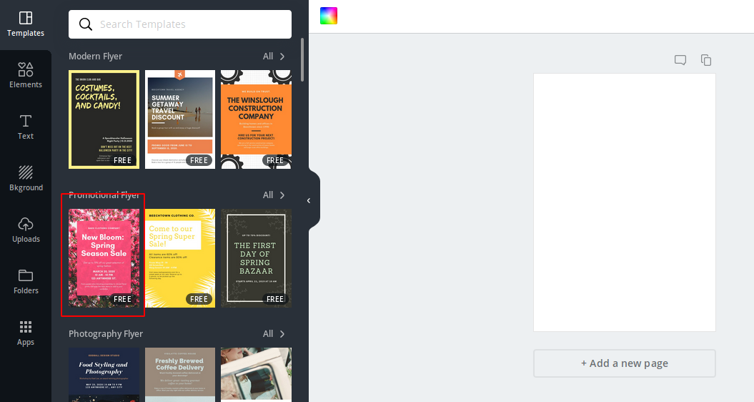

So this is our template. Click each text and start editing according to your attributes.

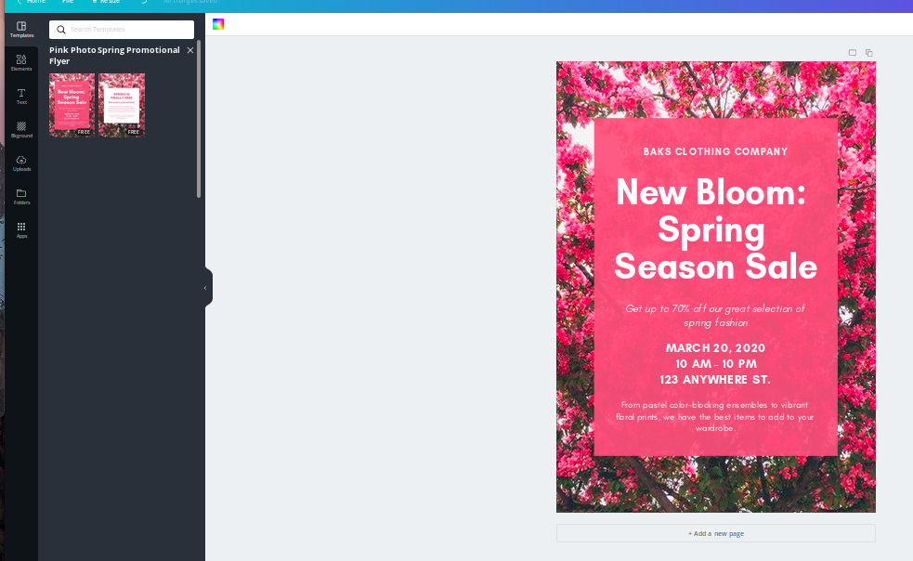

If your name is Faiyaz the house name will be Faiyaz Fashion

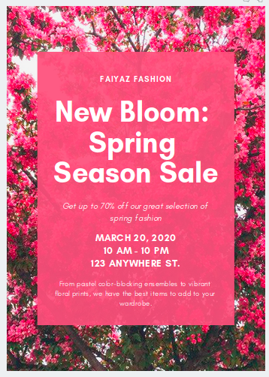

Write your offer name

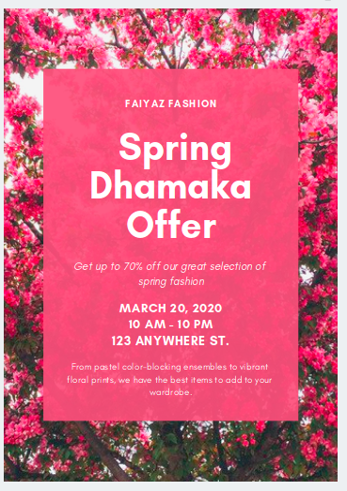

Write about your promotion and discount

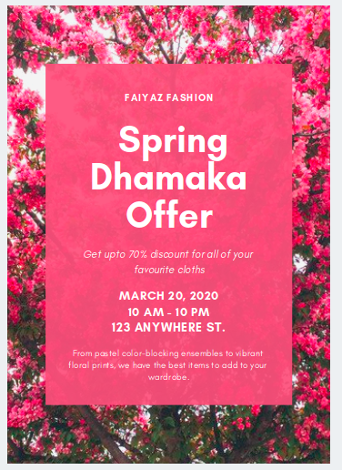

Mention time , date and address

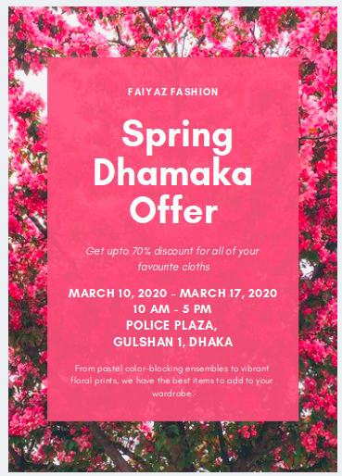

Delete unnecessary text from the template.

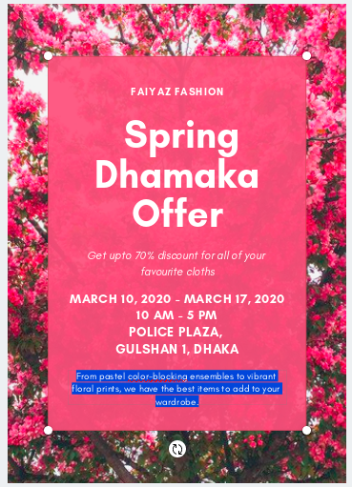

Click publish > download > file type > jpg > download > save to extract your poster.

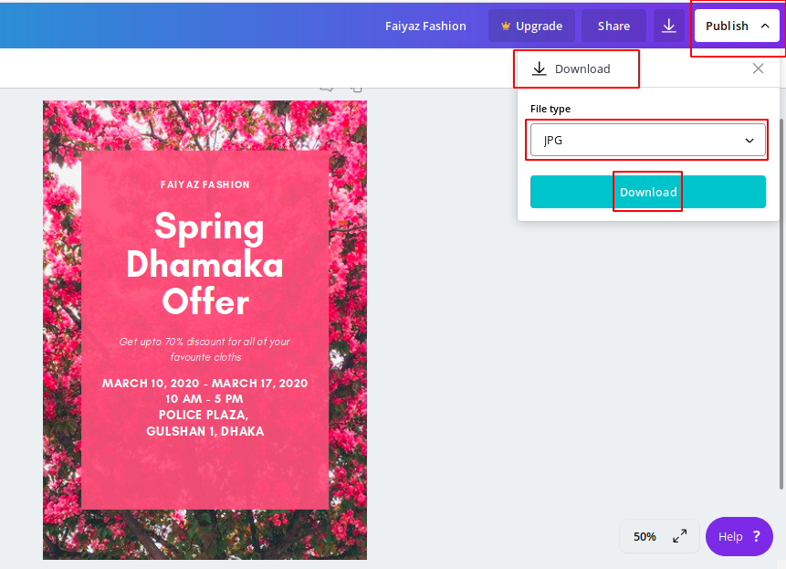

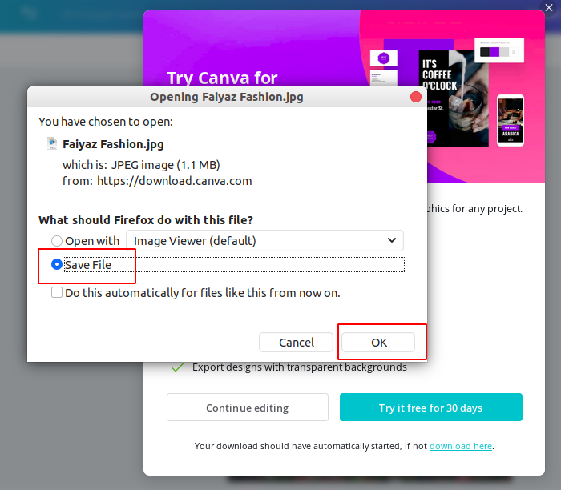

Finally your Flyer type poster

